

**Software Design Document**

**Booking Hotel web PROJECT REPORT**

# Group 1

Đỗ Hoàng Sơn

Đoàn Quang Nhật Minh

Trần Quang Huy

Nguyễn Trọng Hiếu

Công Hậu

– Da Nang, June 14th 2022 –

**Table of Contents**

I. Software Design Document 3

1. System Design 3

1.1 System Architecture 3

1.2 Package Diagram 3

2. Database Design 3

3. Detailed Design 6

3.1 Class Diagram 7

3.2 Sequence Diagram 8

# I. Software Design Document

## 1. System Design

### 1.1 System Architecture

*[The content of this section includes the overall diagram which includes the sub-systems, the external systems, and the relationship/connection among them. You need also provide the explanation for each of the diagram components (modules, sub-systems, external systems, etc.)].*

### 1.2 Package Diagram

*[Provide the package diagram for each sub-system. The content of this section includes overall package diagram(s) and the explanation for each package (or namespace). Please see the sample and description table format below]*

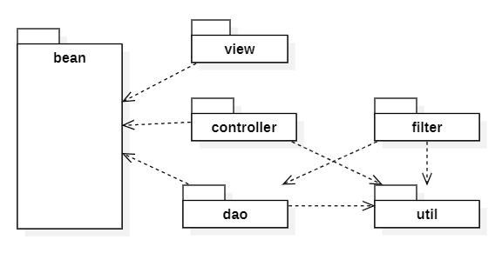

***Package Descriptions***

|  |  |  |
| --- | --- | --- |
| **No** | **Package** | **Description** |
| *01* | *<Package name>* | *<Description of the package>*  *<Class naming convention>* |

1. **Database Design**

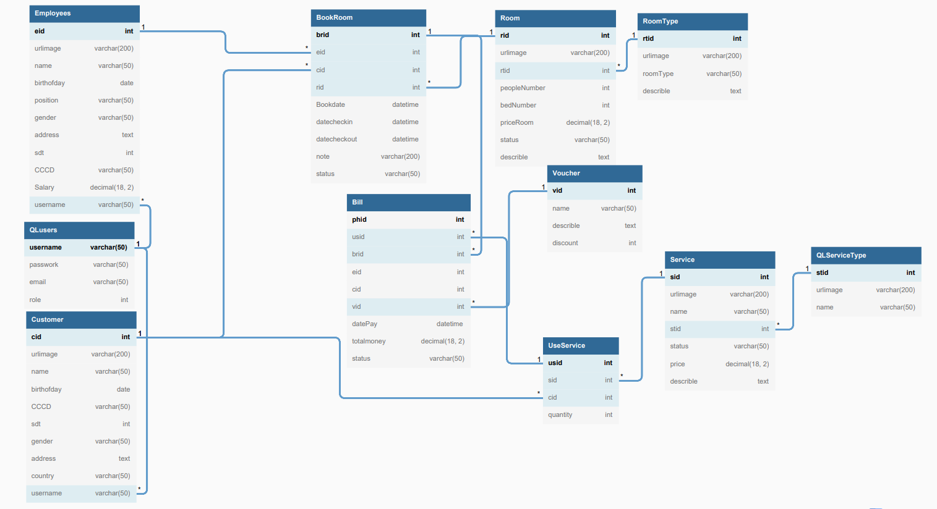

***Table Descriptions***

## 1. <Table QLusers >

|  |  |  |  |  |  |  |  |
| --- | --- | --- | --- | --- | --- | --- | --- |
| **#** | **Field name** | **Type** | **Size** | **Unique** | **Not Null** | **PK/FK** | **Notes** |
| 1 | username | Varchar | 50 |  |  | PK |  |
| 2 | password | varchar | 50 |  |  |  |  |
| 3 | email | varchar | 50 |  |  |  |  |
| 4 | role | Int |  |  |  |  |  |

## 

## 2. <Table Employees>

|  |  |  |  |  |  |  |  |
| --- | --- | --- | --- | --- | --- | --- | --- |
| **#** | **Field name** | **Type** | **Size** | **Unique** | **Not Null** | **PK/FK** | **Notes** |
| 1 | eid | Int |  |  |  | PK |  |
| 2 | urlimage | Varchar | 200 |  |  |  |  |
| 3 | name | Varchar | 50 |  |  |  |  |
| 4 | birthofday | Date |  |  |  |  |  |
| 5 | position | Varchar | 50 |  |  |  |  |
| 6 | gender | Varchar | 50 |  |  |  |  |
| 7 | address | Text |  |  |  |  |  |
| 8 | sdt | Int |  |  |  |  |  |
| 9 | CCCD | Varchar | 50 |  |  |  |  |
| 10 | Salary | Decimal | 18,2 |  |  |  |  |
| 11 | username | Varchar | 50 |  |  | FK |  |

## 3. <Table Customer>

|  |  |  |  |  |  |  |  |
| --- | --- | --- | --- | --- | --- | --- | --- |
| **#** | **Field name** | **Type** | **Size** | **Unique** | **Not Null** | **PK/FK** | **Notes** |
| 1 | cid | Int |  |  |  | PK |  |
| 2 | urlimage | Varchar | 200 |  |  |  |  |
| 3 | name | Varchar | 50 |  |  |  |  |
| 4 | birthofday | Date |  |  |  |  |  |
| 5 | CCCD | Varchar | 50 |  |  |  |  |
| 6 | sdt | Int |  |  |  |  |  |
| 7 | gender | Varchar | 50 |  |  |  |  |
| 8 | address | Text |  |  |  |  |  |
| 9 | country | Varchar | 50 |  |  |  |  |
| 10 | username | Varchar | 50 |  |  | FK |  |

## 4. <Table BookRoom>

|  |  |  |  |  |  |  |  |
| --- | --- | --- | --- | --- | --- | --- | --- |
| **#** | **Field name** | **Type** | **Size** | **Unique** | **Not Null** | **PK/FK** | **Notes** |
| 1 | brid | Int |  |  |  | PK |  |
| 2 | eid | Int |  |  |  | FK |  |
| 3 | cid | Int |  |  |  | FK |  |
| 4 | rid | Int |  |  |  | FK |  |
| 5 | Bookdate | Datetime |  |  |  |  |  |
| 6 | datecheckin | Datetime |  |  |  |  |  |
| 7 | datecheckout | Datetime |  |  |  |  |  |
| 8 | note | Varchar | 200 |  |  |  |  |
| 9 | status | Varchar | 50 |  |  |  | Cancelled,booked,out of date |

## 5. <Table Room>

|  |  |  |  |  |  |  |  |
| --- | --- | --- | --- | --- | --- | --- | --- |
| **#** | **Field name** | **Type** | **Size** | **Unique** | **Not Null** | **PK/FK** | **Notes** |
| 1 | rid | Int |  |  |  | PK |  |
| 2 | urlimage | Varchar | 200 |  |  |  |  |
| 3 | rtid | Int |  |  |  | FK |  |
| 4 | peopleNumber | Int |  |  |  |  |  |
| 5 | bedNumber | Int |  |  |  |  |  |
| 6 | priceRoom | Decimal | 18,2 |  |  |  |  |
| 7 | status | Varchar | 50 |  |  |  | Empty,full |
| 8 | describle | Text |  |  |  |  |  |

## 6. <Table RoomType>

|  |  |  |  |  |  |  |  |
| --- | --- | --- | --- | --- | --- | --- | --- |
| **#** | **Field name** | **Type** | **Size** | **Unique** | **Not Null** | **PK/FK** | **Notes** |
| 1 | rtid | Int |  |  |  | PK |  |
| 2 | urlimage | Varchar | 200 |  |  |  |  |
| 3 | roomType | Varchar | 50 |  |  |  | Name of type room |
| 4 | describle | Text |  |  |  |  |  |

## 7. <Table Bill>

|  |  |  |  |  |  |  |  |
| --- | --- | --- | --- | --- | --- | --- | --- |
| **#** | **Field name** | **Type** | **Size** | **Unique** | **Not Null** | **PK/FK** | **Notes** |
| 1 | phid | Int |  |  |  | PK |  |
| 2 | usid | Int |  |  |  | FK |  |
| 3 | brid | Int |  |  |  | FK |  |
| 4 | eid | Int |  |  |  | FK |  |
| 5 | cid | Int |  |  |  | FK |  |
| 6 | vid | Int |  |  |  | FK |  |
| 7 | datePay | Datetime |  |  |  |  |  |
| 8 | totalmoney | Decimal | 18,2 |  |  |  |  |
| 9 | Status | Varchar | 50 |  |  |  | Sold, Pending |

## 8. <Table Voucher>

|  |  |  |  |  |  |  |  |
| --- | --- | --- | --- | --- | --- | --- | --- |
| **#** | **Field name** | **Type** | **Size** | **Unique** | **Not Null** | **PK/FK** | **Notes** |
| 1 | vid | Int |  |  |  | PK |  |
| 2 | name | Varchar | 50 |  |  |  |  |
| 3 | describle | Text |  |  |  |  |  |
| 4 | discout | Int |  |  |  |  |  |

## 9. <Table UseService>

|  |  |  |  |  |  |  |  |
| --- | --- | --- | --- | --- | --- | --- | --- |
| **#** | **Field name** | **Type** | **Size** | **Unique** | **Not Null** | **PK/FK** | **Notes** |
| 1 | usid | Int |  |  |  | PK |  |
| 2 | sid | Int |  |  |  | FK |  |
| 3 | cid | Int |  |  |  | FK |  |
| 4 | quantity | Int |  |  |  |  |  |

## 10. <Table Service >

|  |  |  |  |  |  |  |  |
| --- | --- | --- | --- | --- | --- | --- | --- |
| **#** | **Field name** | **Type** | **Size** | **Unique** | **Not Null** | **PK/FK** | **Notes** |
| 1 | sid | Int |  |  |  | PK |  |
| 2 | urlimage | Varchar | 200 |  |  |  |  |
| 3 | name | Varchar | 50 |  |  |  |  |
| 4 | stid | Int |  |  |  | FK |  |
| 5 | status | Varchar | 50 |  |  |  | Over,even |
| 6 | price | Decimal | 18,2 |  |  |  |  |
| 7 | describle | Text |  |  |  |  |  |

## 11. <Table QLServiceType>

|  |  |  |  |  |  |  |  |
| --- | --- | --- | --- | --- | --- | --- | --- |
| **#** | **Field name** | **Type** | **Size** | **Unique** | **Not Null** | **PK/FK** | **Notes** |
| 1 | stid | Int |  |  |  | PK |  |
| 2 | urlimage | Varchar | 200 |  |  |  |  |
| 3 | name | Varchar | 50 |  |  |  |  |

1. **Detailed Design**
   1. **Class Diagram**

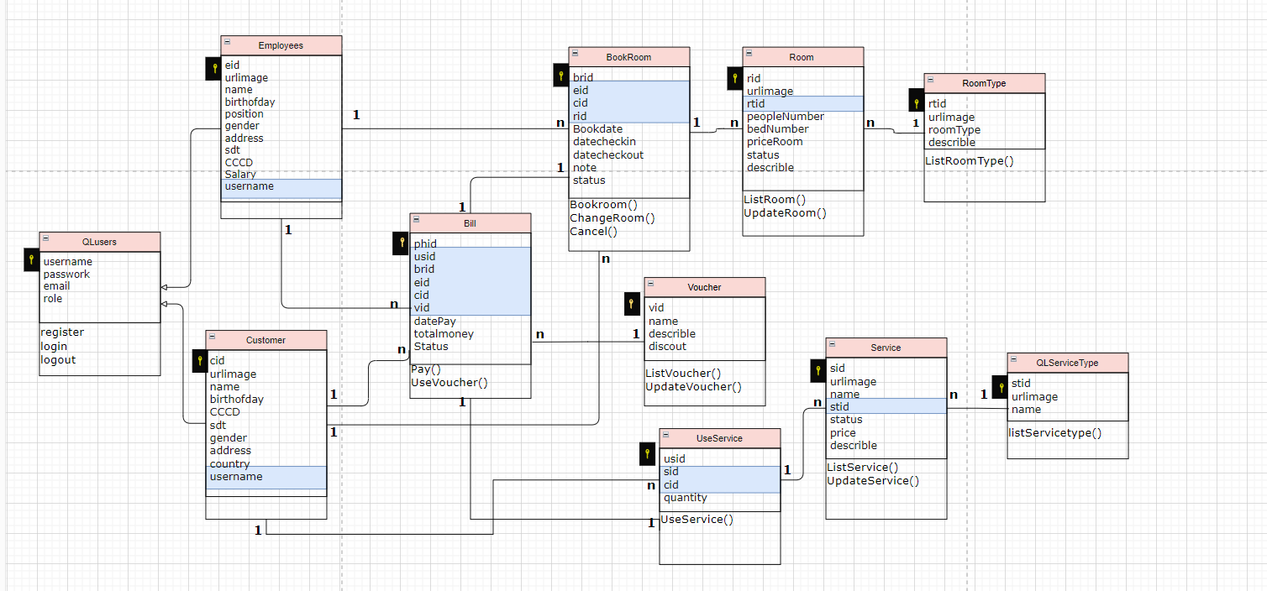

#### **QLusers Class**

|  |  |  |
| --- | --- | --- |
| **No** | **Method** | **Description** |
| 01 | Login | Dùng để đăng nhập tài khoản vào trang web |
| 02 | logout | Dùng để đăng xuất tài khoản khỏi trang web |
| 03 | register | Dùng để đăng ký tài khoản vào trang web |

#### **Bill Class**

|  |  |  |
| --- | --- | --- |
| **No** | **Method** | **Description** |
| 01 | Pay | Dùng để thanh toán tiền |
| 02 | UseVoucher | Dùng để giảm giá các thành phần có trong bill |

|  |  |  |
| --- | --- | --- |
| **No** | **Method** | **Description** |
| 01 | Bookroom | Dùng để đặt phòng |
| 02 | ChangeRoom | Dùng để đổi phòng khi đã đặt phòng |
| 03 | Cancel | Dùng để hủy phòng đã đặt |

**BookRoom Class**

|  |  |  |
| --- | --- | --- |
| **No** | **Method** | **Description** |
| 01 | ListRoom | Dùng để xem danh sách phòng |
| 02 | UpdateRoom | Dùng để cập nhật phòng |

**Room Class**

|  |  |  |
| --- | --- | --- |
| **No** | **Method** | **Description** |
| 01 | ListRoomType | Dùng để xem danh sách các loại phòng |

**RoomType Class**

**Voucher Class**

|  |  |  |
| --- | --- | --- |
| **No** | **Method** | **Description** |
| 01 | ListVoucher | Dùng để xem danh sách voucher |
| 02 | UpdateVoucher | Dùng để cập nhật voucher |

**UseService Class**

|  |  |  |
| --- | --- | --- |
| **No** | **Method** | **Description** |
| 01 | UseService | Dùng để sử dụng dịch vụ |

**Service Class**

|  |  |  |
| --- | --- | --- |
| **No** | **Method** | **Description** |
| 01 | ListService | Dùng để xem danh sách dịch vụ |
| 02 | UpdateService | Dùng để cập nhật dịch vụ |

**QLServiceType Class**

|  |  |  |
| --- | --- | --- |
| **No** | **Method** | **Description** |
| 01 | listServicetype | Dùng để xem danh sách các loại dịch vụ |

* 1. **Sequence Diagram**
     1. **Payment**
     2. **Booking Room**
     3. **Add/Update/Delete**